GUIDELINE FOR QOOXDOO IDE INSTALLATION

SPKET

Version | Content | Date | Editor
1.0 | Create document | 21 Oct 2010 | Thinh Nguyen

- Download IDE
IDE Link: http://www.agpad.com/downloads/spket-1.6.18.jar
- Install
  - Run by double click on downloaded file or by DOS command:

java –jar [file path]\spket-1.6.18.jar

b. Follow the opened wizard and finish installation.

- Configuration

a. Download qooxdoo SDK: http://qooxdoo.org/download

b. Create JavaScript profile
- Select the menu item Window > Preferences... to open the workbench preferences.
- Select the Spket > JavaScript Profile preference page to display the installed JavaScript Profiles.
- Click the New.. button. In the Name field, type qooxdoo as the name for the new profile. Then click OK.
- Click the Add Library button. From the Library drop-down list, select qooxdoo. Then click OK.
- Click the Add Folder button, choose the folder.
- Select the qooxdoo profile created in step 3, click the Default button make it the default profile for all project. The default profile can also be configured per project by using Configure Project Specific Settings... link.
- Click on OK to save the preferences.
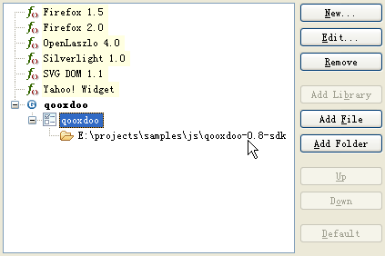

4. Features

Code assist: The code assist list all the built-in class with full documentation.

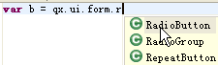

Code assist for properties: The code assist will list all the properties and where it was defined.

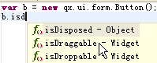

Open declaration: Select qooxdoo function, use the Ctrl+Click combination or F3, you can jump to the qooxdoo source code, help you to learn how qooxdoo works.

